January marked a tough start to the year, but there is lots to be positive about
We saw in national headlines, there have been increases in calls to National Debtline by an astonishing 57% in the first two weeks of January, compared to the same period last year. At REACH we saw increases in levels of people receiving food parcels; in December 2024 we saw a 35% rise, and January 2025 33% rise on the previous years. In addition, we saw just over a 30% increase in new debt cases.
Valerie is in her 80s, and popped into The Link when we were there on the off chance that we could help her. In her case she was concerned about a utility bill, but by dropping in for advice, we were able to do a full check to ensure she was getting what she was entitled to, and even call the utility company on her behalf.
As she left she asked if she could leave some feedback: “Can I just say how valuable REACH is to me as an older person. I don’t know what I would have done without your service here in Haverhill. You’re all brilliant, amazing, and I can’t thank you enough.”
While these figures remain stubbornly high, it is important to recognise these figures reflect people we have helped or are currently supporting, so people are importantly coming forward and allow us to support and work alongside them to lift them out of financial hardship and crisis.
Introducing our new Welcome Spaces
At the start of this month we have refreshed our food collection and drop-in’s and launched our brand new Welcome Spaces!
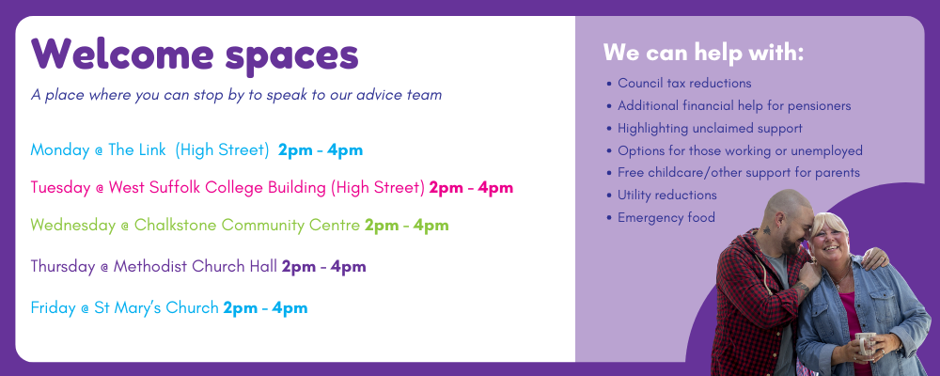
So what is a Welcome Space?
Our Welcome Spaces are open between 2pm-4pm Monday to Friday and each afternoon. We will be at a different venue across the town and hosting our Welcome Space, which is open to everyone. Whether someone would like to pop in and speak to our advice team, pick up emergency food or simply pop by for a cuppa and a chat – we want everyone to feel welcome and comfortable asking for help.
Working hard to get pounds back into our clients’ pockets
Last year we saw the launch of our Income Maximisation team, who do fantastic work getting pounds back into our clients pockets. They can support in a variety of ways whether it be support clients apply for benefits they are entitled to or helping them apply for social tariffs to reduce the cost of their household bills.
Between October 2024 and January 2025, the team of 3, have managed to get just shy of £570,000 back into the pockets of people in and around Haverhill.

Advocating for change
While we continue to support the community here in Haverhill, we are advocating to tackle some of the root causes of why people may need support from REACH.
Locally we work alongside the Haverhill Mental Health Action Group, we are moving closer to achieving one of the main priorities of a Wellbeing Hub.
We continue to work alongside Suffolk County Council to support their count-wide Tackling Poverty Action Plan. While nationally, we engage with Trussell and Joseph Rowntree Foundations ‘Guarantee Our Essentials’ Campaign.

https://www.bbc.co.uk/news/articles/c3rwx31ypy3o#:~:text=Helpline%20calls%20from%20people%20worried%20about%20debt%20have,January%20compared%20with%20the%20same%20period%20last%20year.

